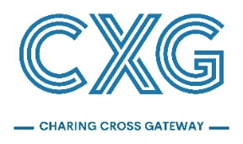

Thank you for completing our feedback form. You will see below that we have left space for you to leave your name and address, as well as your email address. This is optional and these details will not be used for marketing purposes. The findings of our analysis will be shared with Glasgow City Council as part of the pre-planning application public consultation report. We will process any personal information provided on this form and it will be recorded solely for the purpose of the public consultation analysis and in accordance with the General Data Protection Regulation (GDPR). Your details will be removed from our database at your request.

Please submit forms no later than 10 November 2023. You can submit feedback forms on the website, via post to Hannah Fisher at The BIG Partnership Group Limited, 1 – 3 Woodside Crescent, Glasgow, G3 7UL or via email at charingcrossgateway@bigpartnership.co.uk. A further opportunity to make representations to the Council will be available when the planning application is submitted.

Name:
Email:
Address:
Postcode:

Did you attend our last information session? Yes/No (please circle)

To what extent do you agree that the Charing Cross area requires regeneration?
- Strongly agree
- Agree
- Strongly disagree
- Disagree
- No view either way

To what extent do you agree that the Charing Cross area would benefit from investment?
- Strongly agree
- Agree
- Strongly disagree
- Disagree
- No view either way

What is your overall impression of the developed proposals?

Please turn over

Which elements of the proposals appeal to you?

Are there any elements of the proposals that do not appeal to you?

Is there anything you would like to see incorporated into the proposals that is not already included?

How informative / helpful have you found our public consultation?
- Very informative
- Informative
- Not informative
- Don’t know

Please let us know if you have any additional feedback or comments, below.

